Voltage divider schematics:

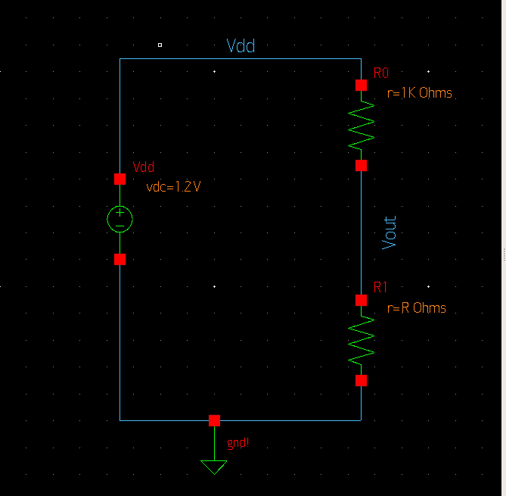

Voltage divider SAE for source sweep:

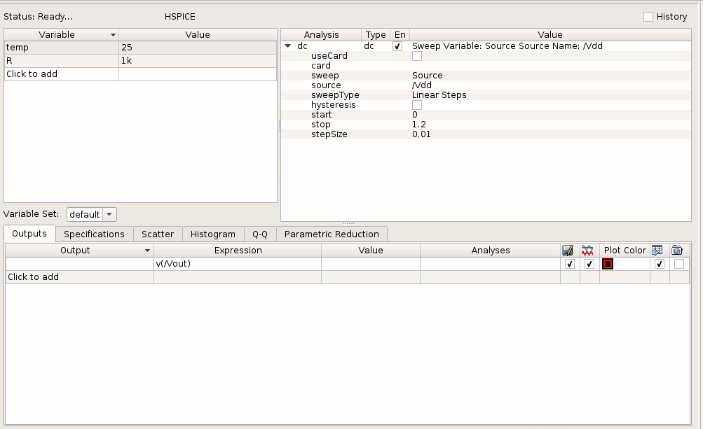

Voltage divider SAE for resistance sweep:

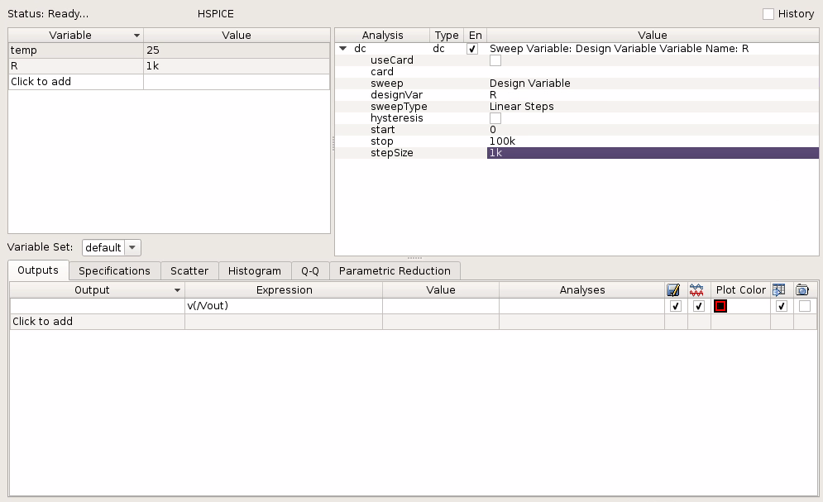

Voltage divider simulation 1:

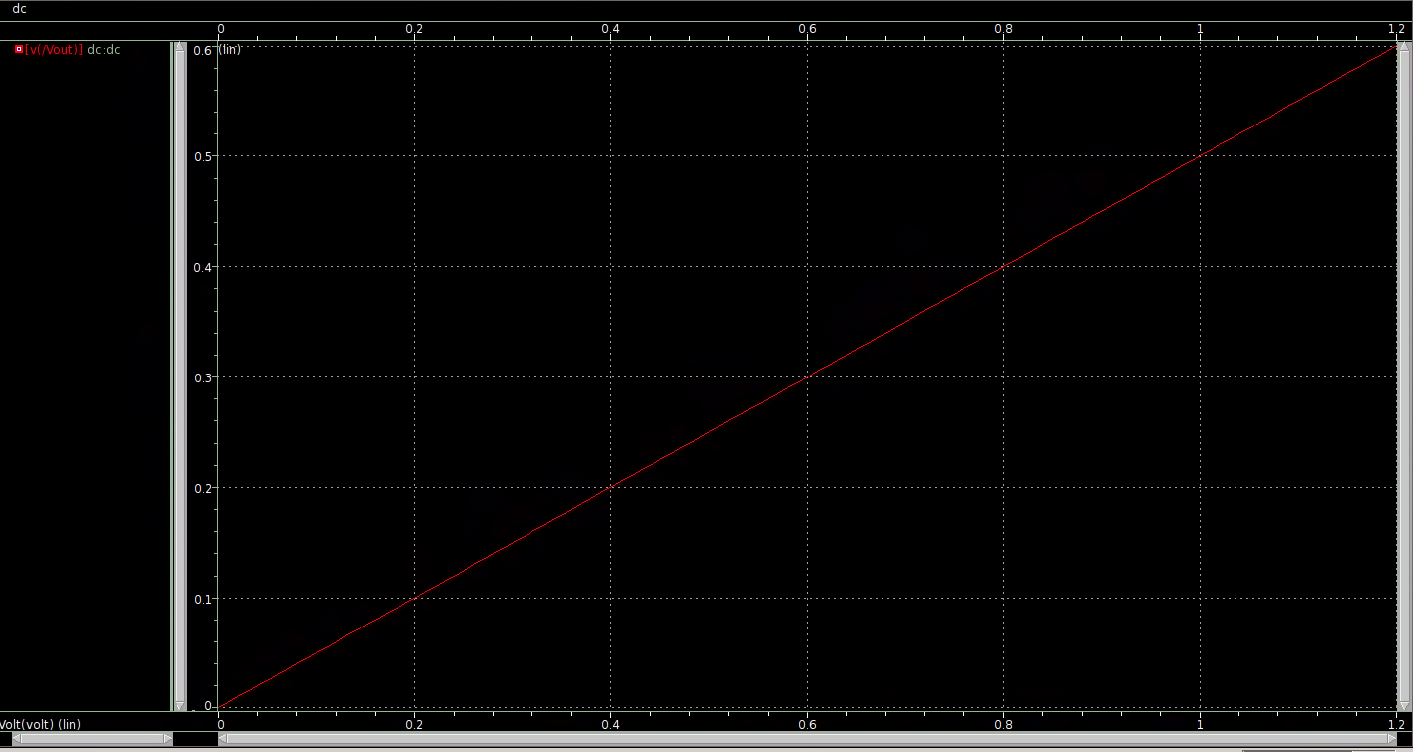

Vdd = 0.2 V, Vout = 0.1 V

Vdd = 0.6 V, Vout = 0.3 V

Vdd = 1.0 V, Vout = 0.5 V

Vdd = 1.2 V, Vout = 0.6 V

Voltage divider simulation 2:

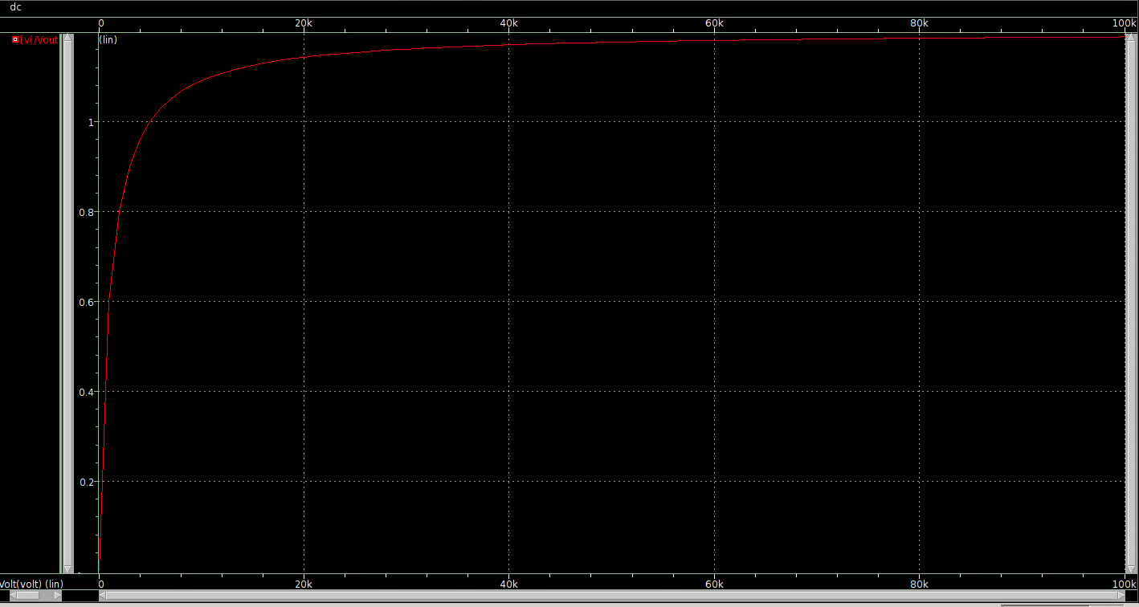

R = 0 ohms, Vout = 0 V

R = 100 kohms, Vout ≈ 1.2 V

RC Network schematic:

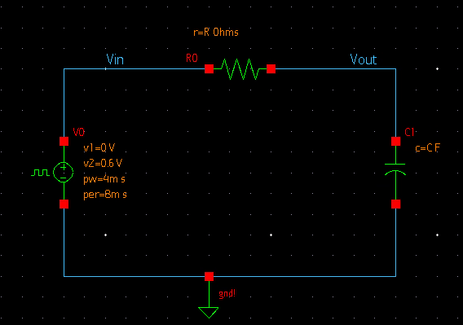

RC Network SAE for resistance:

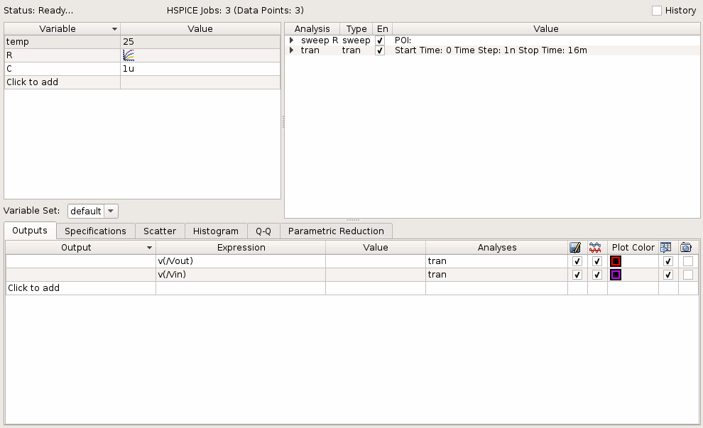

RC Network SAE for capacitor:

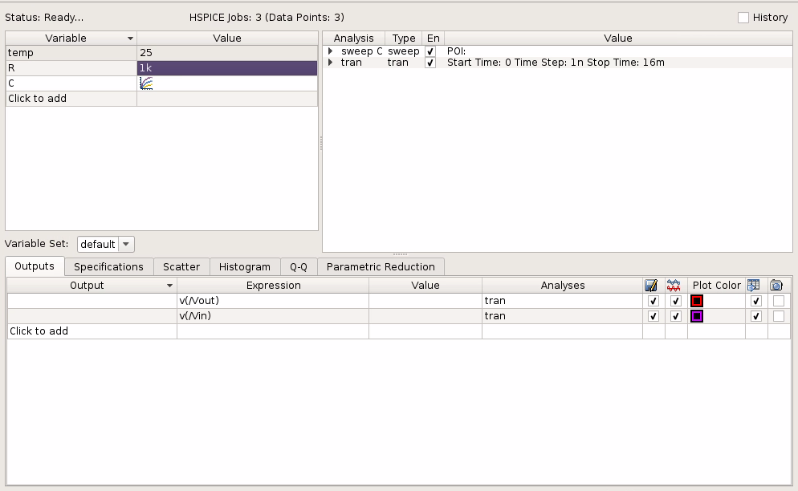

RC Network simulation 1:

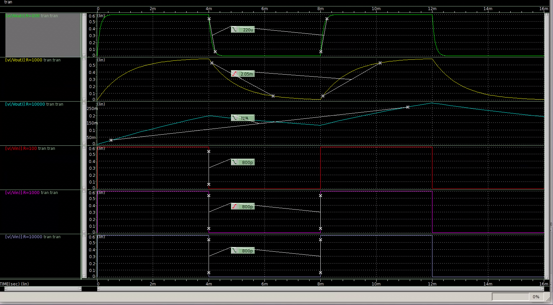

Rise and fall time is the time it takes to go from 10% charge to 90% charge and 90% to 10% charge. There’s an error when R = 10K since the resistance is so large that it takes the capacitor a very long time to go from 10% charge to 90% charge.

Vout when R = 100 ohms, t = 220 us

Vout when R = 1k ohms, t = 2.05 ms

Vout when R = 10k ohms, t = N/A

Vin when R = 100 ohms, t = 800 ps

Vin when R = 1k ohms, t = 800 ps

Vin when R = 10k ohms, t = 800 ps

RC Network simulation 2:

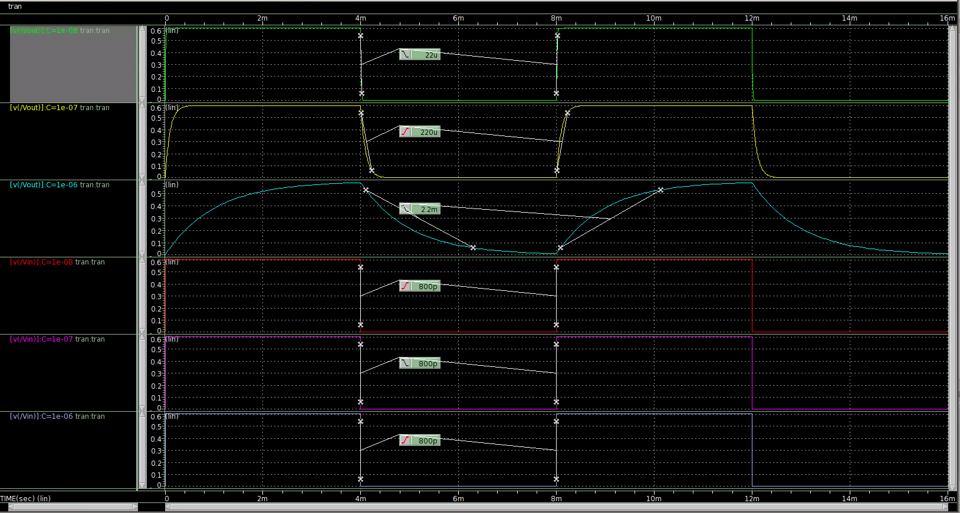

Vout when C = 0.01 uF, t = 22 us

Vout when C = 0.1 uF, t = 220 us

Vout when C = 1 uF, t = 2.2 ms

Vin when C = 0.01 uF, t = 800 ps

Vin when C = 0.1 uF, t = 800 ps

Vin when C = 1 uF, t = 800 ps

Conclusion:

When the resistance in a RC circuit is large, it takes the capacitor a longer time to charge and discharge.